VisualMuse Innovations

Spencer Earl

WDD 130

Overview

Purpose

I am building a personal website that will serve as a high-impact digital portfolio for my photography and artwork. This site will feature a clean, minimalistic design that will allow for the featured projects to speak for themselves. Categorized by project type, this website will feature a high-resolution image gallery as well as a form to contact me. The goal is to create a professional, accessible online space for potential clients, galleries, and collaborators to easily view my various creative works.

Audience
Galleries, potential clients, artists, and photographers

Branding

Website Logo

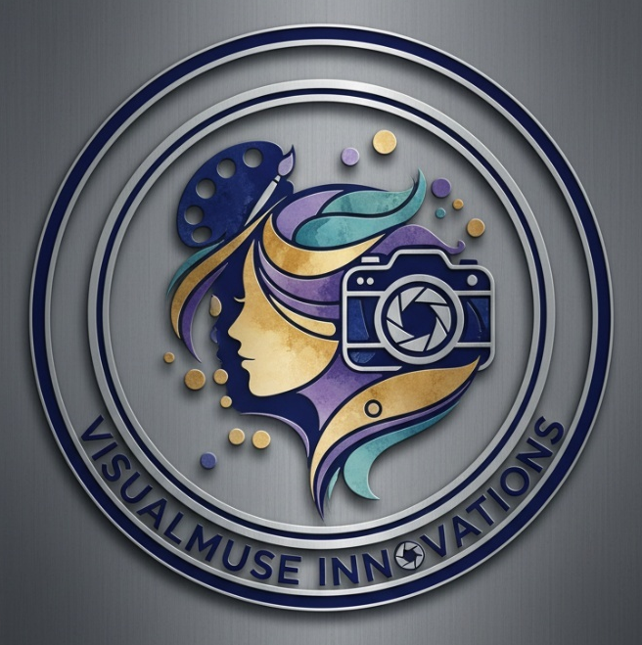

Style Guide

Color Palette
Primary | Secondary | Accent 1 | Accent 2
#3C2A6F | #56A8A4 | #C8A359 | #8C6AA1

Typography

Heading Font:

https://www.dafont.com/milven.font

Paragraph Font:

https://www.dafont.com/comfortaa.font?text=VisualMuse+Innovations

Navigation
Home – Home page where viewers can see my artist statement as well as learn more about the business.
Artworks – This will be a page where the viewers can see my different pieces of work that I have made over the years.
Photographs – This will be a page where the viewers can see my photographs that I have to be displayed in my portfolio.
Products – This will be the page where viewers can see the different products that I have available for purchase, and there will be a link that will take them to that specific product in my Etsy shop.

Content
Artist Statement:
My practice is dedicated to the exploration of intricate abstract designs through pencil work, ballpoint pen drawings, etc. I also focus on photography in various genres including landscape, portraiture, commercial, etc. I am fundamentally driven by a desire to inspire others around me to take the time to capture the beauty of the world around us, as well as the joy and beauty that comes from each and every individual. My work seeks to offer viewers a moment of reflection, as well as inspiration and joy, encouraging a deeper engagement with the often-overlooked details of the human experience.
The execution of my work is a meticulous journey that prioritizes slow, fine lines and repeating patterns, as well as framing, background, and other techniques in my digital photography. I primarily utilize fine-tip pencils or mechanical pencils, ballpoint pens, fine-tip pens, etc. for my traditional art pieces, and using digital photography equipment such as a DSLR camera, tripod, photoshop, etc. in my digital photography. This deliberate choice of materials is central to the narrative, often contrasting bold colors with black and white. Through my artistic lens, I aim to not simply depict, but to more fully and emotionally exhibit the complexities inherent in our personal lives as well as all-in-all in the world around us.

Photos:
https://photos.app.goo.gl/uZqsYum2uCw8Lgp26

Links:
Floral Skull Digital Print
Black and White Ceiling Fan Digital Print
O’Keeffe Skull Tattoo Digital Print

Wireframes

Home

